**Practical No.7**

Write a program that implements the banker’s algorithm

Input:-

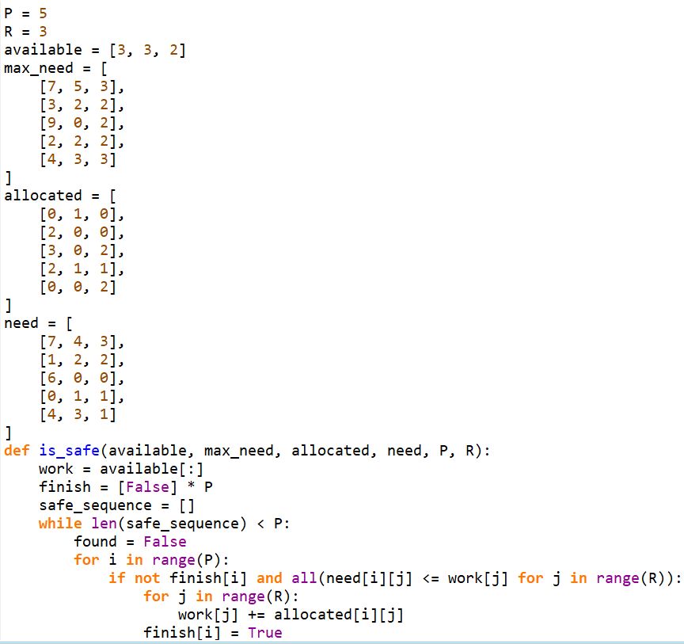

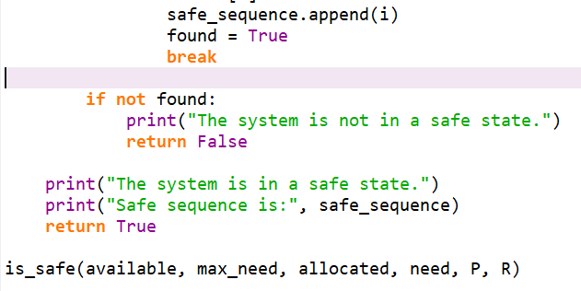

Output:-

